BOO – a wake-up call to finding and working with my inner bad ass monk

It changed for me the day that Mary walked past my window, as I sat inside working and shouted ‘boo’. Whether it was at my cat, who was outside, or at me, I can’t tell you. Still, I can tell you that it was 7am, it did make me jump a little, but more importantly made me take check and realise that it was all somewhat bizarre. I’d thought it was a man’s voice, the depth and loudness of it, and after the cat meowed at the window, I let Joey, our cat in, and on seeing the brake lights from their parking area, I assumed it was Mary’s son. Not that long later, as we were heading out paddle boarding, I saw it was Mary’s car that had moved, so can only have been her shouting. And it fits the picture of what was going on.

Whilst it may have made me jump, it didn’t come from nowhere. Things had shifted two and a half years ago for me. That said, they’d happened for others earlier, in our street, and I’m sorry I was unaware of them at the time. I would like to hope that I’d have spoken out then, had I been. Now if not then, I know I’m there for anyone going through anything similar to this.

It went on for what felt like forever, with really nothing that changed. Or at least nothing that I was aware of between Mary and I. Having said that, nothing may have changed for many people then, but my world had changed for me. Not, at that point, anything to do with Mary or her behaviour, though I am infinitely grateful to her for powering me onwards afterwards.

The last time she was really pleasant, consistently at least, to both myself or my partner, was at a BBQ at the end of May, that I’d co-arranged with my now partner, then neighbour. I’d suggested coffee and cake, he’d suggested BBQ, we co-ordinated the dates and invited all the neighbours to a street BBQ. My partner’s neighbour had all the gear, the big BBQ station, table and chairs and the rest. He volunteered to use his BBQ for most of the food – I’d been going to bring along a camping chair, picnic table and tin foil BBQs, so compared to my lowly plan, it was looking good. People brought food and drinks along, shared company and it went on into the night, going really well.

We’ve (myself and my then 11 year old daughter) eaten a plant based diet for years, and so our food was on a separate grill. Steve, now partner, then neighbour offered to take care of our burgers and sausages, and – the idea of a break from cooking was tempting, I jumped at the chance. My own relationship had been cooling for a little while, my boyfriend was lovely, but it didn’t feel like things were going anywhere, and I’d realised it wasn’t right for me. Is it too cheesy to say that over a hot BBQ, the sparks started flying?! Probably a bit much, after all we’re barely even introduced. Anyway there was a connection, more conversation and I still remember him looking at me, smiling, whilst talking, as it happened, to Mary and saying that he was happy here, he had everything he needed here.

We, Steve and I, talked more over the coming days and by late June, had the most romantic first date I’ve ever had. We had by then become tentative friends, and had swum together in the river, with friends, and my small family. Conversation was easy, there was lots to chat about and I admired his love of the outdoors. He was a can-do type, and whilst I didn’t understand his job (I still don’t –my daughter and I still say he works with money), he’s a lecturer in economics, I was enjoying spending time in his company. I had realised the relationship I was in wasn’t working (before the romantic first date) and had voiced this with my then boyfriend, although not formally finished it. Timing was a challenge with distances, and work and school and the rest. It felt best to speak face to face, which unfortunately meant there was a tiny cross over. Was this what was going on when I got my first glare from Mary? It was whilst I was sat outside as I was finishing the relationship. I said hi and there was a stony silence and a glare. A judgement of me? I don’t know. Do you know what though? It’s all been worth it. But that’s the first time I remember something different in the dynamic with Mary.

Having realised that things weren’t going places and I needed to finish the relationship I was in, I didn’t know this was going to work, but did know I needed to be with someone slightly more dynamic – or to be by myself, which I wasn’t scared of. My husband and I separated before our daughter was one, and I’d done a lot of being by myself with her. We’d had a lot of fun and travelled together around the country – and world, with our furthest trips taking us to Canada and Australia. So I could do just me, just fine.

Shall I share the first date details? It’s not everyone’s cup of tea – dancing and cocktails suit others more… but for me it was perfect. We’d suggested a night swim, I won’t share the location as it’s not a place you’re perhaps supposed to swim now. As I was going to be in London for a meeting the day of the swim, and wouldn’t have parental responsibilities that night, I suggested an early morning dog walk the next day, before I got back to mum duties again. Then I did one of those spontaneous suggestions that Steve tells me he loves about me. What if we camped out? Went to swim, wild camped and then came back the following morning. Less than 12 hours away but a whole world away all in one. We swam in the moonlight, it can’t have been a full moon, as we’d swum with friends under the full moon a few days before, but it was beautiful. Skinny dipping in the moonlight is one of my very favourite things. We dried off, and drove off, to a spot Steve had found and checked out with the farmer the day before. Camping on the hillside, Steve later told me that pitching the tent together was a test – if we could do that we’d be OK. We managed it zero arguments, drank non gin G&T and watched the moon set whilst talking… lots. It was only a few hours later that I was awake watching the sunrise – and I do like to share. So we did. A cuppa and the tent put away and that was it. Back to reality. After a drive back down the dales and my first introduction to one of his favourite groups – Above and Beyond.

The date itself probably was above and beyond really. I’d been collected from the station around 9.15, when the London train got in, and having previously given my sleeping bag to Steve, he’d packed up and we were good to go. He’d thought of everything and it was wonderful. He even did that (car) door opening thing for me. You might argue I can open my own, and of course I can, but to be treated like I was special for a moment was really lovely. It’s funny how he’ll do things like that, from a training in ‘good manners’ for my independent daughter, and get a metaphorical kick in the nuts for it. Hmmm. Loving her bad ass streak! She has it in spades, where, well I have it barely. Hence my mission here.

I’m pretty peaceful, prefer harmony over harassment, which is pretty funny really considering the last 2 and a half years. So then the ignoring began more so. Occasional really I think to start and I’d question whether I was picking up on something that wasn’t there. By the following summer, after we’d had the craziest, most brilliant, uncomfortable, growing, amazing trip with good friends – who are fortunately still good friends, and returned from Greece to find that Mary had cleaned a path between our houses. I asked if it was her that did it, and thanked her it, to then receive the ‘Paddington stare’ (you know the one – intended to make the recipient feel uncomfortable etc) and a ‘yes’, whilst she retreated and slammed the door. Aha, no doubt now, definitely a certain issue.

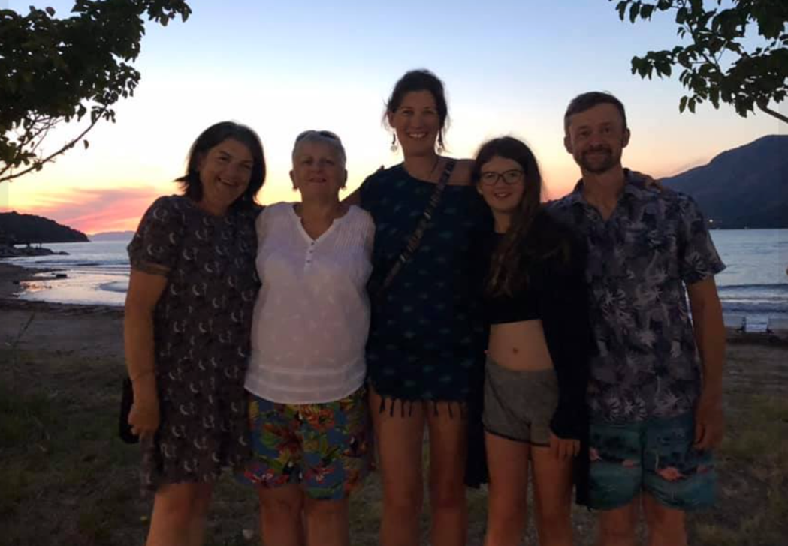

I remember in the July there’d been a certain level of discomfort, but as Steve had a special birthday that year, and as we were celebrating at home and I was inviting the other neighbours, I wasn’t going to leave Mary out and invited her too. Of course she didn’t come, which was fine, but I’m not a person that doesn’t include someone. By the August, and the first door slamming, I was in the picture.

______________

And so the real ignoring began. The over excitedly talking to, greeting and chatting with other neighbours whilst we were in the vicinity. The blanking. It was all a bit odd really and I racked my brains. Was it because I’d suggested we might re-wild the banking by our houses and she thought I was taking some kind of control? I’m a community spirited type and like people working together, where they want to, though not everyone appreciates that. Was it because the postman had asked me to ask all other neighbours to clean the paths in front of their houses as they were a slip hazard. Mary’s was apparently fine he told me, but the rest needed doing else we wouldn’t have the post delivered. Perhaps I was being too this, too that? I had put chalks out in our community car park and used to draw pictures on the ground. And hopscotch. I did walk past one time, when another pair of neighbours were chatting over Mary’s fence, and overhear them discussing that it was a place to park cars only. Or something similar. Maybe it was nothing to do with me, though the ‘Paddington stare’ was again fully utilised.

I have a vision of people living nearby, working together and helping each other out. Others are different and I guess I’m learning that. Maybe we’ll have that another time. When we’d first moved into our house, 13 years ago it had been just like that. Doors were left open, kids would be in someone’s house, though quite probably not their own, brews and problems would be shared on the doorstep. There were a few single mums, although Mary wasn’t here back then, she came to live in the street several years later. We’d hang out, chat and support each other. I used to take and collect my immediate neighbours children from school and have them back at mine whilst she worked. Back then I was still trying to get my business up and running and was taking on bits of work here and there. I had trained as a homeopath and qualified when my daughter was 6 months old but working around recently becoming a single parent, looking after my daughter and providing for us meant I did things to fit around being a mum, not diving into business quite as fully as perhaps had I not been doing those other things.

Back to Mary and I, for now, after a while of the awkwardness from me, and the showing us how awful we were from her, I decided enough, and one day followed her saying ‘Mary, I know you can hear me, I’m sorry if I’ve upset you’. That was way back in September 2019. I didn’t pick my time brilliantly when I look back, there were others around and I guess that meant she’d been called out on her behaviour a bit, so perhaps my bad. But enough of the BS. Anyway, not so long after, I was heading out for a meal with Steve and we met on the path. I stood to one side, and said ‘after you’. In return I got a ‘If you ever speak to me again, I’ll do you for harassment’. Ahh not quite the ‘thank you’ most would give then. ‘Harassment?’ I queried. ‘I didn’t say arrested, I said harassment’ was the response. ‘I’ve never harassed anyone in my life’ I retorted by now puzzled and shaking inside, as I knocked on Steve’s door. As I told him, and subsequently another neighbour who was somewhat shocked by the exchange she was stood by her car, she was shouting ‘Oh deary me, oh woe is me, oh poor me’ in a mocking tone. All seemed mighty strange.

Things continued in a similar way, and come February 2020, I’d acknowledged Mary a couple of times with a small wave of my hand (politely, as a greeting not in any more fun fingers up manner), she pulled her car up to me and told me that I should stop behaving like an idiot and desperately trying to get her attention. Hmmm. But anyway.

I got really rattled the time during the first lockdown when, admittedly we’d been out a few times that day, to shop for food, to walk the dogs, and to take my daughter to visit her father and bring her home. I was walking past her house with my daughter, Mary was outside saying loudly “get that camera on Jane, you know why”. Back at that point we reached out again to the police, then decided not to pursue things as they might just get worse. I’d already met with a Police Community Support Officer and had chosen just to log things.

I guess something that has bothered me, and led to me creating this concept, is that others wouldn’t have been bothered. I have some awesome bad ass women in my life who wouldn’t have entertained a sniff of this, wouldn’t have cared. Would perhaps have stamped it out before it even began. It bothered me though, and at times took me back to places of remembering when my ex-husband would threaten taking me to court over a couple of things. I’d end up shaking, upset, and also frustrated at myself that I felt like that. What do some have that I don’t? I’ve always been fairly gentle, tend to be an optimist, like looking after people, but that bad ass thing is less present. My dad does it in a great way, and appears to take things in his stride. Totally unoffended when Mary muttered ‘what a weirdo’ about him in his hearing, I was indignant. ‘How dare she? Does she not know who he is?’

The illusion started to break down for me in October 2020. I was walking to my car as she was coming to the house, she turned to her son and said ‘don’t go near that cat’. ‘why?’ he asked. I had had enough by now of playing some kind of victim status and being told what to do, intimidated etc. I responded ‘apparently it’s vicious’. ‘It is vicious’ she responded. Then the following unfolded. ‘Don’t speak to me’. ‘No’, I said, ‘I will, you can’t stand in your garden shouting that we’re bullies’. ‘Well, that cat is a bully. I feel intimidated going past your house’. My daughter had by this time gone inside to find my partner, and she emerged from our house. ‘Our cat isn’t a bully’. ‘Your minor should not be speaking to me’, was the response, ‘get your minor away’. ‘I’m filming this for evidence’. ‘That’s good’, I responded, ‘I’ve already spoken to the police about your behaviour’. ‘Oh good, you’ll have a case number too then’. ‘Yes, I do’. ‘I’ve got video evidence of your cat being a bully’. ‘It’s a cat. Can we not just talk about this and clear it up?’ ‘Look at you full of your own self importance’. ‘I’m not, I’m about the least self important person I know’. ‘Get down off your high horse, you’re so full of your own self importance, you’re speaking to everyone and trying to get them on your side’.

So by now, I guess I was fairly aware this wasn’t massively rational. But I was rattled by the filming as she went past our house, which started a while before the exchange. Surely you can’t film as you walk around, especially getting children on camera. Well, apparently you can. As long as you’re not on someone else’s property, you can do what you like. By this point though, I really had had enough and I spoke to the police to try and do what I could to stop this behaviour.

I felt better than if we’d involved them earlier – for a start, I’d tried to sort it out myself, had grown stronger through the process, but appeared clear that this wasn’t likely to just be resolved, and appeared to be getting worse with the filming – and also the walking past our house muttering at me through the window things like ‘never miss a bloody trick, nosy mcnosy, do you have to be so bloody nosy’. Talk about nosy! There’d be looking in every time on going past, and reversing right in front of the house for no particular need, certainly not to get into the parking space she was heading into.

So a PCSO came, seriously I’m going to really sound like a middle aged woman when I say about how young he looked, I could have been his mother! He pleasantly listened, chatted and visited both houses, where he advised each of us not to engage with the other. The filming could continue and we were advised to get a camera doorbell so we’d pick up on behaviour if it occurred and could be used to show it was happening as opposed to our word against hers. He did tell us as he left hers, she came back into the garden and shouted ‘thanks for coming and sorry to waste your time’. Typical Mary! He had clocked the behaviour though, and reassured us that likely she wouldn’t escalate from the comments to other forms of behaviour and hoped she’d follow his advice.

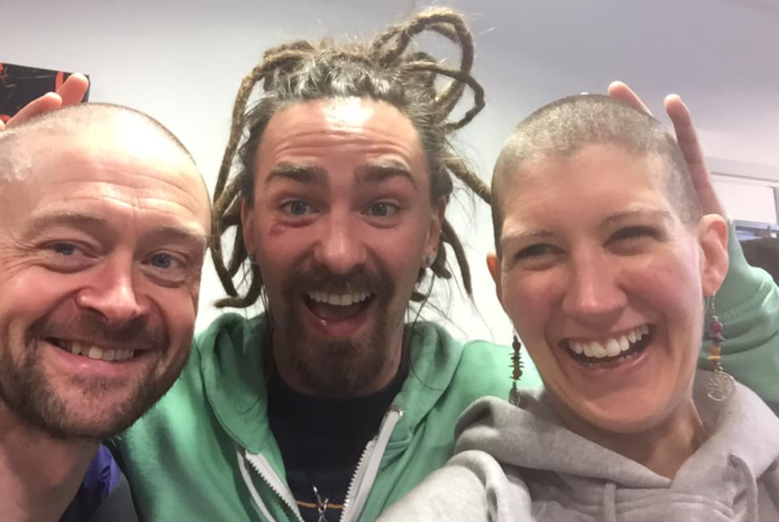

Things had impacted on us on a mental and emotional level and as ever I’m grateful for the support of my parents, for some amazing friends, for my partner, was neighbour. I’d begun to lose more hair than I should have done at the end of 2019, and on seeing an appeal from an NGO I have supported in the past decided ‘sod it, I’ll shave it off and raise some money’. Steve joined me and together we raised £4000 for Homeopathy for Health in Africa. So some great things hopefully came out of that. I also got to shave my head which I’d wanted to do for a while, and not back out at the last moment as had £s hanging over it. I’d done some work with a friend, now trained psychotherapist and worked with a technique she’d gone to Italy to train in, working with soul collages. I definitely recommend it for processing things, accepting ourselves and moving through challenging situations. I’d used Byron Katie’s The Work – which is simply brilliant too. And also of course working with The Four Agreements and The Fifth Agreement.

My daughter, on moving to our new house, with her bedroom a floor below ours, had found that difficult, and was worried Mary would break in or do something to the house whilst she was asleep. It had definitely increased her anxiety levels, and I’m ashamed to say that my worry about the situation had impacted on her too.

So even more reason to harness my inner bad ass monk.

I think it was a day before the ‘boo’, that I realised I’d done all I could with what I had, the tools at my disposal. I’d tried kindness, understanding, I’d worked with Pierre Pradervand’s Gentle Art of Blessing, Ho’opono’ono, I’d tried apologising, I’d tried being quiet, I’d tried speaking up. And nothing worked. The day the police came, ironically, or with some beautiful synchronicity, I’d set up a what’s app group with my sister (formerly a police officer) and mum, and called it ‘boo’ and had fed back to them both. That was Tuesday before Mary’s catalyst of a ‘boo’ on Saturday. How funny this life is. But it was the Friday before the boo day that I realised I needed more tools.

My degree was in Psychology and Neuroscience, and I studied it because it fascinated me. I’d had a life plan from the age of 7 and knew I was on the right track. For 10 years at least. I got to 17, and realised I didn’t want that. I remember the exact moment, stood at the side of a vet, arm shoulder deep into a horse’s backside (the vet’s arm, not mine), and realising that I was more interested in how the people were behaving than what was going on inside the horse. By that stage I had wanted to become an equine acupuncturist and realised that I had to change plans. Realising people intrigued me sent me on a look at Psychology courses. It was Manchester’s joint honours degree that really made me excited. There was something about holding their prospectus that was different to the others. And so I set off, with my gut response telling me I was where I was supposed to be.

I met some incredible people there, and have chatted just this morning to one fabulous woman I met and lived with for three years, then travelled with for months afterwards. I had no idea what I was going to do after the degree – my life plan no longer mapped out, travelling in Australia was a good enough idea and I did that.

So people and possibilities. I think we can learn pretty much anything, and as a homeopath, teaching others things, I will so often say that if you can learn to practice homeopathy, you really can do anything. It’s seriously the most amazing, complex, beautiful thing I’ve come across. So learning. I think it’s the way forwards. Being uncomfortable with being a beginner is an important thing to cope with, and do again and again. I think there’s something brilliant to be gained from not knowing everything (or at least accepting you don’t know everything). In some ways I’ve an advantage here, I love learning. Always have. I was the kid you told to do their homework and off they skipped. I probably haven’t studied for a couple of years of my life. Since I was 4 anyway. Most of my life I’ve been engaged in study of one sort or another. There is so much I’d love to know and probably never will, which am coming to terms with, but the potential is there for all of us. And whilst often we look at skills as things we can learn, I think everything is possible. OK mostly at least. I was listening yesterday to Brene Brown’s podcast with David Eagleman, neuroscientist, that I pondered more on this. David talks about some skills that there is a definite window for, but for many it’s on my way of thinking, we can do (nearly) anything with practice.

Neuropossibility, I coined it on a doodling with my visioning group, as my idea for the bad ass monk concept evolved. The idea of neuroplasticity combined with hope. The idea we can put the work in and get places we’d never imagined.

Back in 2012, coming out of a relationship in 2011 – on the 11th of the 11th of the 11th, in case you’re intrigued by numbers. Time for a bit of solo time. All about 1. I decided that I’d jump in and have a year that was all about me. All about learning different things, things that I was interested in for me, no one else. By then Isla, my daughter, was 4, nearly 5, and I had a tiny amount more freedom to go do evening classes, or learn things from home. So I took 13 months, starting with learning to knit in December, mindfulness followed in January, February was pole dancing, March crochet… I discovered cycling again, open water swimming, barefoot running, tried a bit more yoga, focussed more on photography, then by autumn it felt like I was still doing so many of these things, I couldn’t ‘do’ more, so played with eating veggie, then was inspired (by a book someone had recommended at open water swimming, that had led onto another book and another book and then I was reading Scott Jurek’s Eat and Run that describes how he ran better, recovered faster whilst eating a plant based diet. Well, if it worked for him, and his ultramarathons then surely it’d be good for me and my local triathlon next year. Let’s give vegan a go too. So I did. And never looked back.

It was, in short, one of the most life-changing years and I discovered communities of people I’d never have done without it. Discovered ways of living that resonated with me on a deep level. Discovered things I wanted to work with, to live with, to explore further. And so I did.

Now, 2021 on the horizon, I realised on the boo day, that the numbers are the same. It’s a 5 year. 2+2+1. I thought I’d do a quick Duck Duck Go search (just doesn’t flow quite the same as ‘google it’ does it?). Here you go:

A key characteristic of the number 5 is curiosity and the need for a variety of exciting experiences in order to feel fulfilled. It craves freedom and adventure and isn't afraid to let the wind carry it where it may. For the 5, life isn't about setting goals and making plans, it's about getting out there and experimenting. Anything that stirs the senses piques the 5's interest and it can't wait to partake in the experience.
The Numerology number 5 is a master of change, able to go with the flow and adapt itself to thrive in different environments and social situations. It is happiest when things feel fresh, high energy, and full of possibility. The moment an experience starts to feel too routine or predictable, the 5 will move on to something more captivating. The only thing this number is truly attached to is being unattached.
Interestingly, in terms of the Tarot:
The number 5 card in a Tarot deck is The Hierophant. He is an advocate of learning and acts as a messenger between the people and the heavens. In Astrology, the zodiac sign Leo is primarily associated with the number 5. Leo is the 5th astrological sign and is an energy force that embraces enjoyment and expression. The signs Virgo and Gemini are also associated with the 5 -- two curious signs that thrive on information and acquired knowledge.

I never realised all that before. So to learn this coming year makes a lot of sense.

What I did realise is that my inner bad ass is pretty weak, she’s not been needed too much. The warrior can be quite strong on the odd email exchange, as I’ve found recently in having to fight for lesser exit terms from school fees – a whole different story. In person though, that warrior is not so strong, I can laugh it off, and have worked hard with that, but in terms of feeling strong inside, not so much. But, back to my own words to others, if you can learn homeopathy, you can do anything. And seriously, if you can learn to speak, to read, to walk, I’m pretty convinced of the same. It’s just work, practice, doing it. So many people now will try something once and abandon it as they’re not good at it. ‘Is it the first time you’ve done that?’ I’ll ask my daughter. ‘Bring it back when you’ve done it a hundred times.’. That said, most times she’s enviably brilliant the first time. That idea of practice and work has been lost in much of our instant gratification society. The inner bad ass monk is going to take a little work.

I have an ability to have an idea and suddenly it’s grown legs, run off with itself, become a book, a series, a health retreat, whilst still not really off the starting blocks. I can sit in a hotel and see how I’d improve it, change that bit, but actually put me in charge of the cash flow and I’m really unsure I’d make it happen. So by the afternoon of the second day ‘find and work with your inner bad ass monk’ had an individualised program, groups to work with and a fully fledged book. Before I’d written a word. I started to write and it flowed. Putting the story on paper was cathartic as it was encouraging. And the power in the adversary had gone. That ‘boo’ had changed it all. But I had power to explore, uncover and realise. And strength to develop. What writing had also done was make any future experiences with Mary fodder for the book. Bring it on.

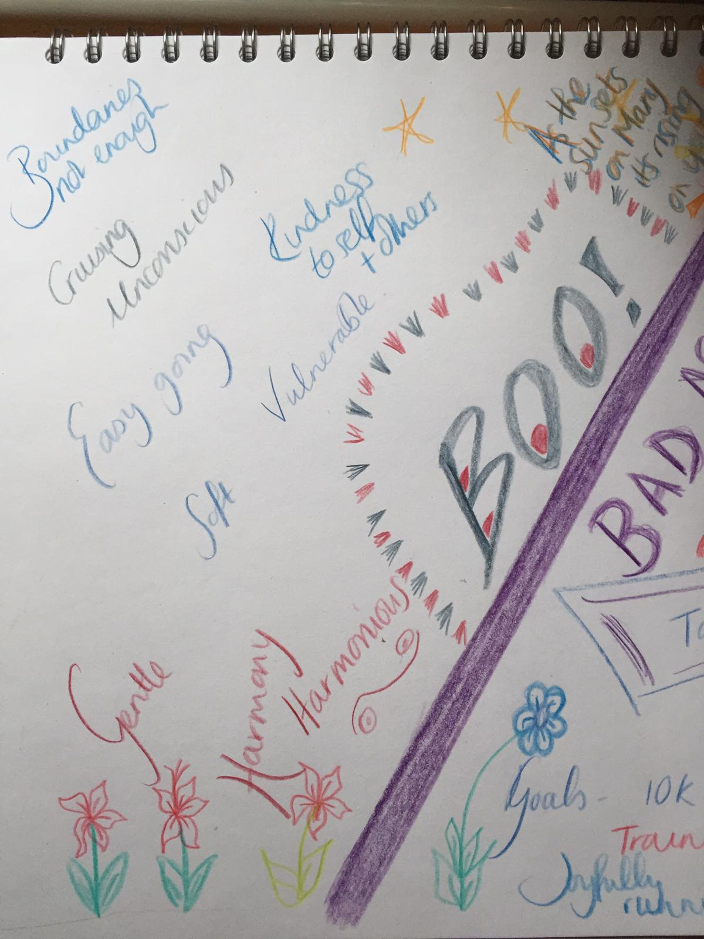

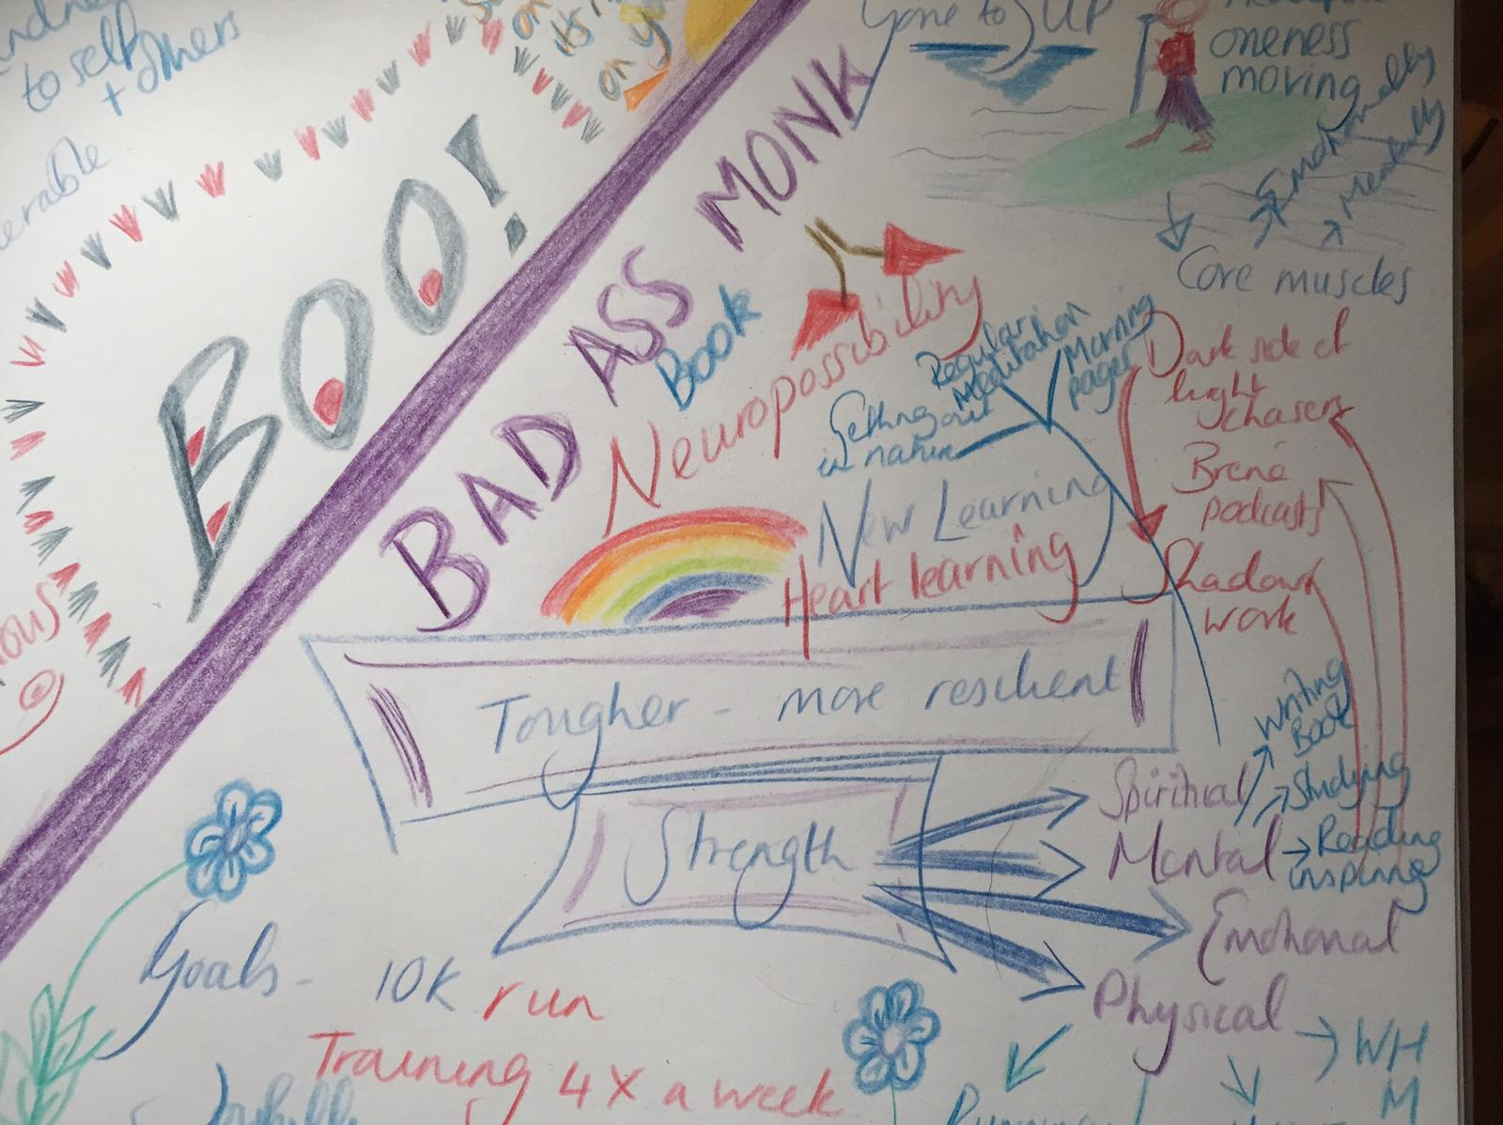

So what does the bad ass monk mean? For me a gentleness and compassion is important. A respect and kindness for the other. But with boundaries, self respect and an ability to say no. And if you don’t mind the language, to be able to say Fuck off. It’s not my stuff. Not taking on the other just because it’s there. You really don’t need to. I did. You might have done in the past, we might both still do it again. But to learn and practice that you don’t need to. To work at it. So my plan is to look at what will help me discover inner strength, focus a month at a time on a different book, activity or practice. A month. After the month if I love it, still want it, I’m welcome to keep it. That way there’s nothing to lose. To experiment without failing because you can’t fail unless you don’t try. That’s the only way to fail at finding you inner bad ass monk I believe. Yoda may say there is no try, there is only do or not do. So do. Step out there, make a fool of yourself here and there, dancing in the park, sing in the street – trust me, it’s liberating. Even if you’re just singing in your head, dancing in your heart, it adds a smile to your face and a joy in your heart. The more you do it the easier it gets.

I believe joy is important. Love. Perhaps joy is love in action. Kindness perhaps is love in action, or maybe a combination of them both. I feel that may be so.

Alongside the yin (gentle, feminine, soft, dark), the yang needs to be in balance for us to be in harmony. The yang is our masculine side, the fire, the light, the perhaps somewhat bolder energies. That fire is gentler in me, so I want to work on that. I want to discover others’ fire. What drives them onwards, where did their bad ass side come from. I want to interview people, to delve into what makes people tick, hear their stories, share their stories.

My feeling is that stories are so key to us as humans. Stories are how we learn, how I learn the best at least. How I find out about people. I love the stories of how people met, how they discovered things, how they developed abilities. And often those abilities, skills came out of the darkest times, the hardest experiences they’d yet had.

I’ve a friend going through tough times at the moment and am grateful to be able to be there for her, not physically currently, but on the end of a phone, an ear when she’s needed it at 6am. Those are the darkest times sometimes. At 5am sometimes. I’m incredibly grateful for those who were there for me during those times, and am glad I can pay a little forwards. I know she’ll come through this stronger, more confident, maybe even happier, and I know that strength isn’t about being strong. It’s keeping on keeping on when it’s tough. We can do amazing things, that we’ve absolutely no idea of, and those tough times, albeit testing, are fertile ground for growth. I look back and can’t believe how far I’ve come since my marriage fell apart. Even now, I’m looking back at how far from the ‘boo’ wake up call I am. How things can change. Just like that.

The bad ass monk might mean different things to everyone, and I like the idea of a questionnaire about what our own needs may be. That’s not here yet, but it may come soon. Let’s see.

For now, I love the idea of grabbing some pencils, pens, whatever you like and sitting with the idea. In mine, I drew a line across it representing before and after the ‘boo’. The change point. Who I was, how I want to develop from here, and what I’ll do to do so. It feels like it’s evolving fast, and whilst I did that on Saturday, now Sunday I’ve more ideas of how it’s going to look for me. I’ll plan to do another now I think. What I want to do is look to nourish both sides this year, the yin and the yang, the bad ass and the monk. So far suggestions include ju jitsu, ta’I chi, nidra yoga, I have restarted my couch to 5K. SIT was suggested but so far a tad hardcore for me, going to look to reinstate HIIT for now. Stand up paddle boarding brings me joy, laughter and good company and exercise.

Fun is important - and laughter. I start a laughter yoga course run by the founder of laughter yoga as a concept in January, so that’s January’s activity sorted.

December I’m planning on reading and working on The Dark Side of the Light Chasers and looking to do some shadow work with that. Damn I think I’m in for another 13 month year!!

I like the idea of a small group of people experimenting with it, if they’d like, or I’m happy just to play. If you’d like to join in, then I’m thinking a monthly get together for an hour or two might work, probably at the turn of the month. We could have a check in on how things have been that month, and what the next is going to focus on. It’s not to say everyone would need to have a 13 month year, could do one focus for the whole year, or have a two month period if that felt better. I know this way works for me, and this is where I’m going.

So far my year looks like this:

December: The Dark Side of the Light Chasers – shadow work
January: Laughter Yoga
February: 5K runs by now (training during Dec/Jan)
March: HIIT focus
April: Becoming Bullet Proof Evy
May: Wim Hof book and more cold water training – back in the drink
June: Martial arts
July:
August: SUP skills
September:
October:
November:
December:

My morning pages has been a useful tool, spurred on by re-starting The Artist’s Way, and I plan to keep this as a part of what I do. Wim Hof, who I discovered during Lockdown take 1, has been a great addition to my day, and I regularly use apps such as Balance (recently discovered and liking it lots) for meditation. These will continue throughout.

Cold Showers (courtesy of Wim Hof method) have been something I’m enjoying – or not so much enjoying but reflecting on being uncomfortable and sticking with that. So often we’re so comfortable in our worlds, in our safe comfort zones, we don’t reach out to others, to other sides of ourselves and I do think these are a wonderful tool to start training our discomfort muscle. I think stepping outside the comfort zone is vital for
I’ve left spaces as I discovered from my last year of discovery, that you find things you want to do as you go along. You follow a path and find a door you’d never seen before, never imagined might be there. So I want room to do that too.

Think Elizabeth Gilbert’s Eat, Pray, Love cross The Battersea Park Road to Enlightenment by Isabel Losada, cross your own how to be a stronger person guide. This is a guide you write yourself, an adventure that is no one else’s.

